National Children’s Hospital – Network Testing Report
---------------------
Student: Jay Keogh
Student ID: C00300208
Date: 02/12/2025
------------------------------

IP Addressing Scheme
Temple Street:
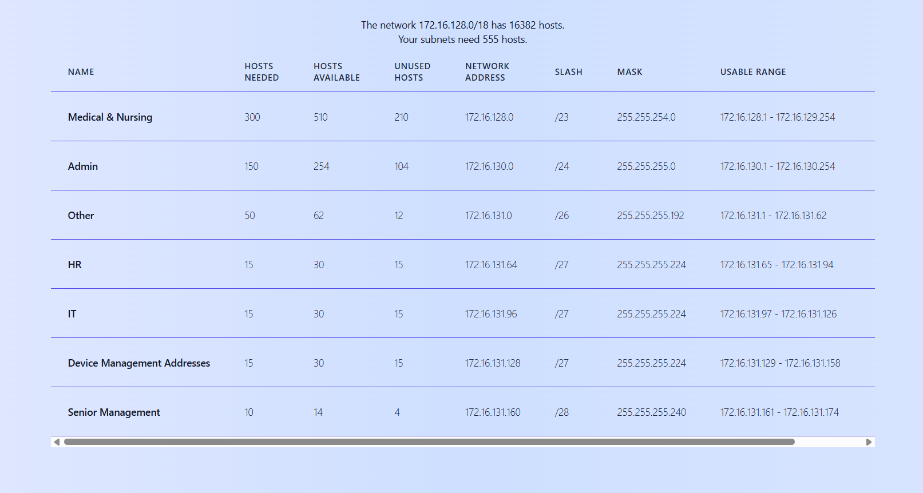
Connolly:
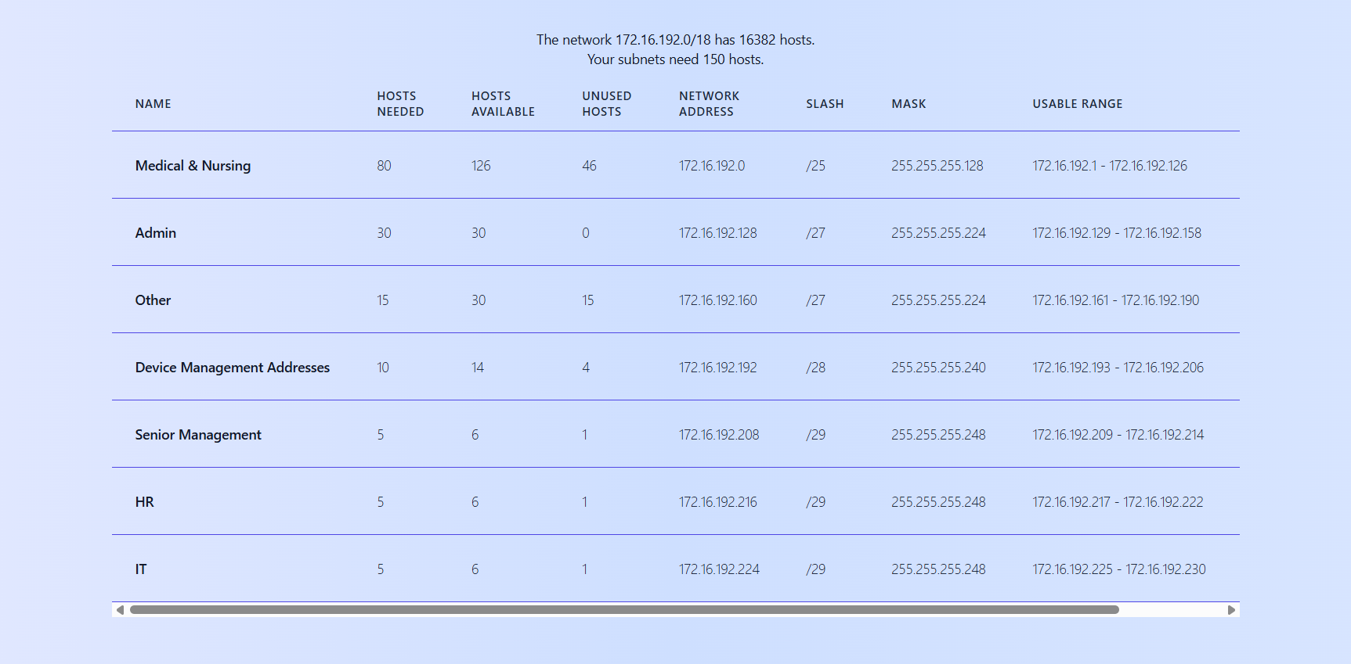

Steps 1 / 2: Inter Vlan Routing + IP Addressing Scheme
S1 (Temple):
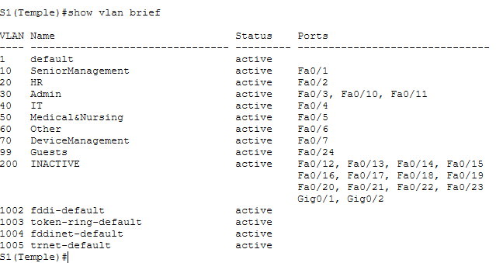
S2 (Temple):
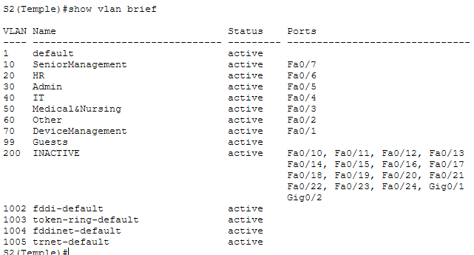
S3 (Temple):
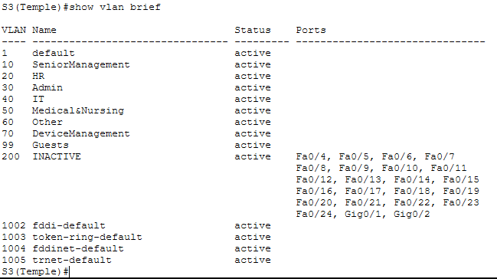

S1 (Connolly):
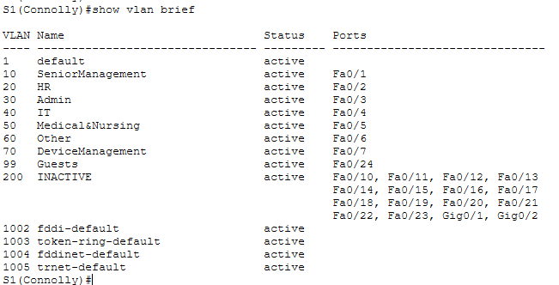
S2 (Connolly):
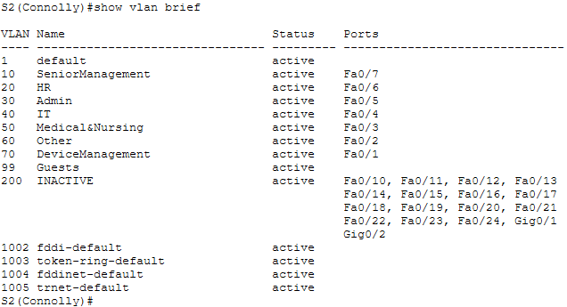
S3 (Connolly):
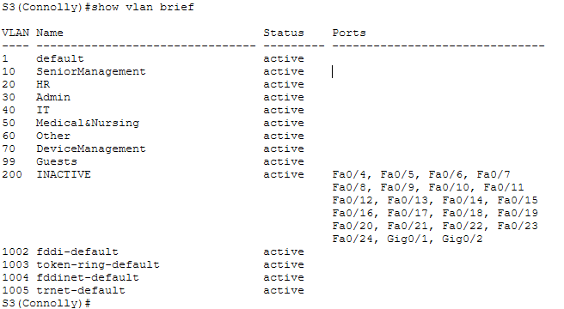

Temple Inter-vlan routing pings:
Ping from Device Management Addresses (T) 2 - > Medical & Nursing (T):
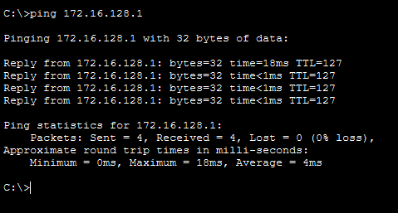
Ping from Senior Management (T) - > IT (T) 2:
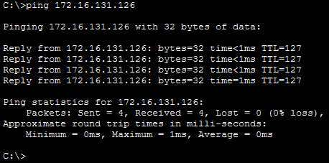

Connoly Inter-vlan routing pings:
Ping from Other (C) -> Device Management Addresses (C) 2

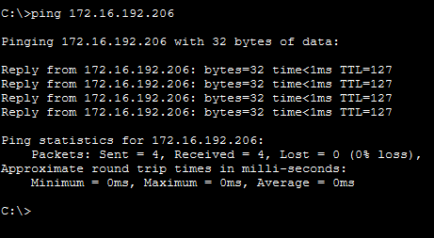
Pings from HR (C) 2 -> Senior Management (C)
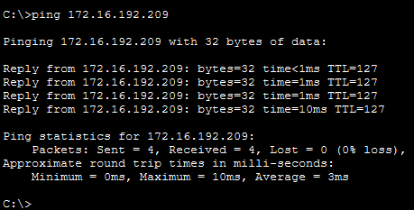

Step 3: Wireless
Vlan 99 sub interface created on Temple Router for Wireless:
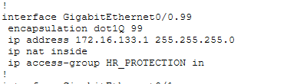
Port Fa0/24 (Port connecting to access point) assigned to Vlan 99:
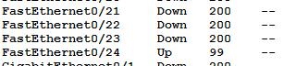
DHCP pool configured on Temple Router for guests using the network:
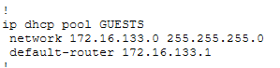
Proof of DHCP assigning IP addresses to the laptops:
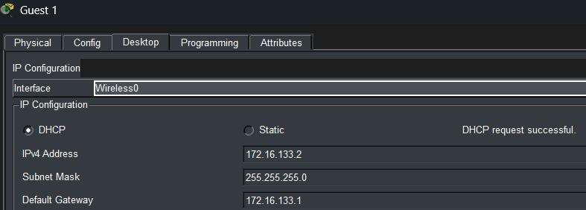
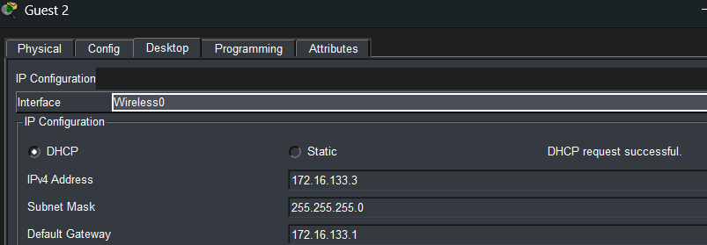
Access Point configured with SSID “Guests”:
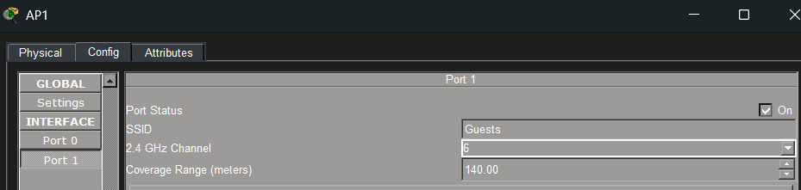
Laptop configured with SSID “Guests”:
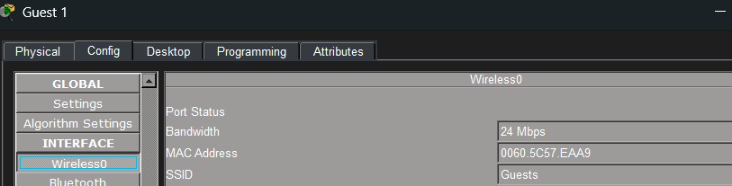

Step 4: NAT/PAT
Temple IP route:
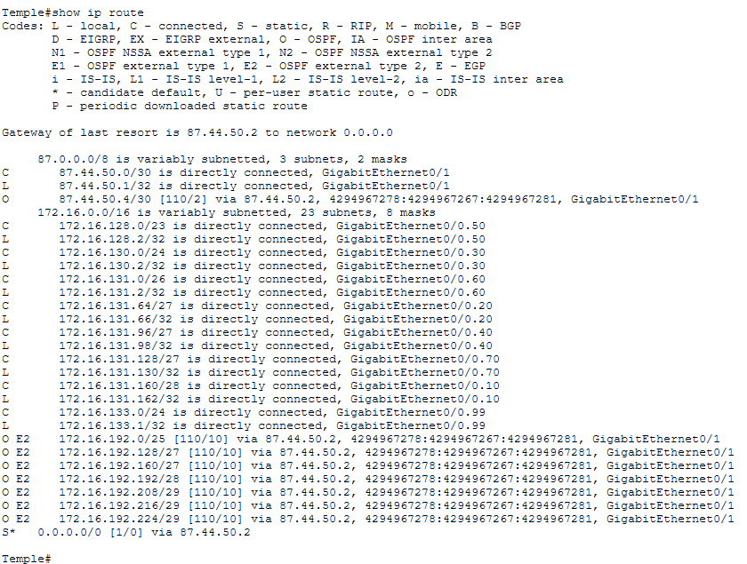
Temple IP Nat translation:
After pinging the internet
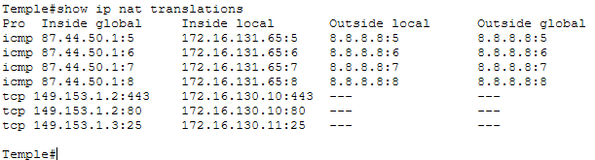

Connolly IP route:
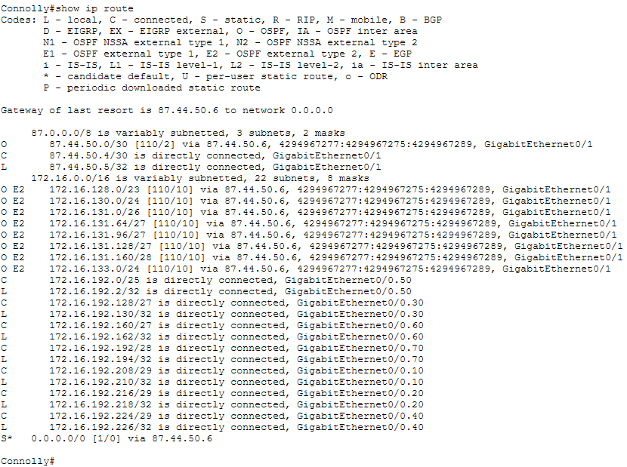
Connolly IP Nat translation:
After pinging the internet, accessing the web using the public IP address of the Web server and Telnetting the public IP of the Email server in Temple Street. All properly translated with Nat.
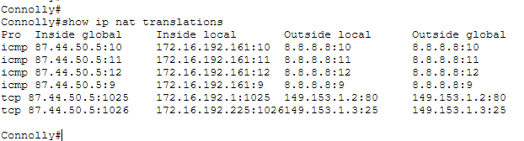

Step 5: VPN Tunnelling
Temple Street show crypto IPsec sa results:
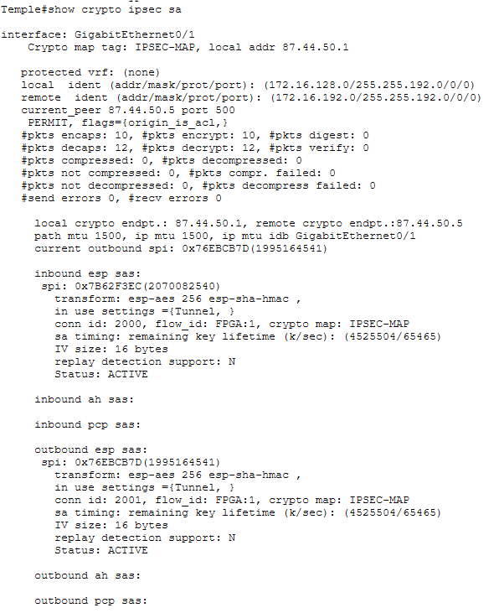
Crypto isakmp commands used for encryption across WAN
On temple:
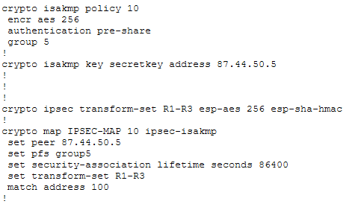
Conolly show crypto IPsec sa results:
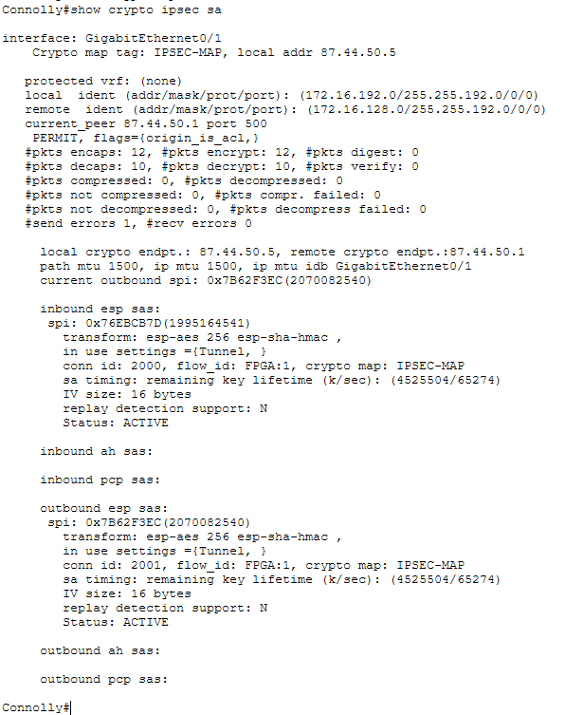
Crypto isakmp commands used for encryption across WAN
On Connolly:
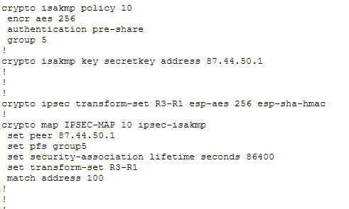

Evidence of packet encrypted over the internet:
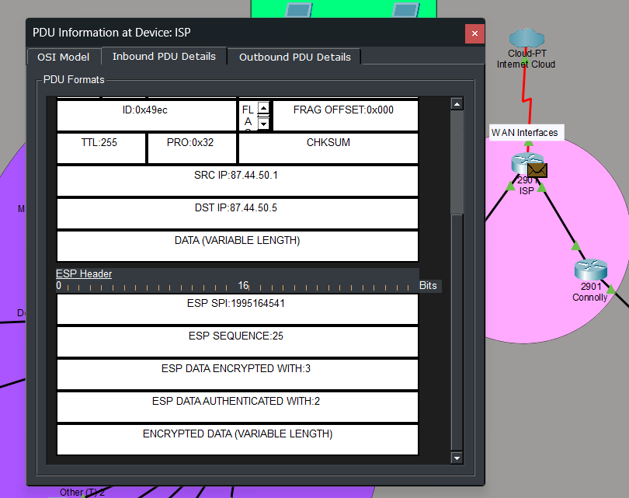

Step 6: Access-lists
(A) “The IT staff should be the only staff members who can access network devices through SSH.”
IT (Temple) Can SSH to Temple router:
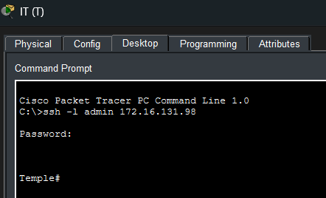
PC’S Other (T) and Medical & Nursing (T) 2 are examples that no pcs can SSH Temple’s router:
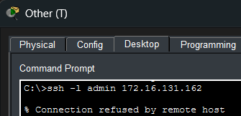
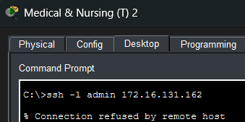
show access-lists SSH_CONTROL on Temple’s router proves it is filtering as intended:
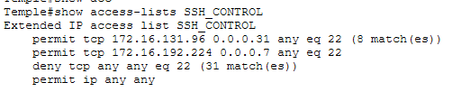
show run | section vty on Temple’s router:
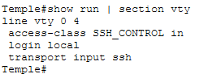
IT (Connolly) Can SSH to Connolly router:
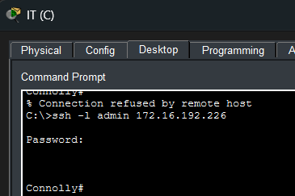
PC’s Device Management Addresses (C) 2 and Senior Management (C) are examples that no pcs can SSH Connolly’s router:
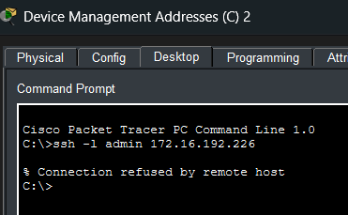
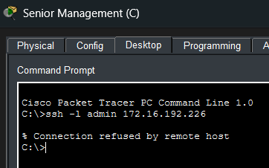
show access-lists SSH_CONTROL on Connoly’s router proves it is filtering as intended:
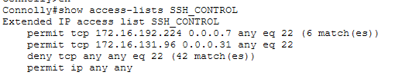
show run | section vty on Connoly’s router:
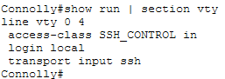

(B) “Block “Admin” staff from accessing everything except for the servers and the Internet.”
Admin (T) can ping the Web server in Temple:
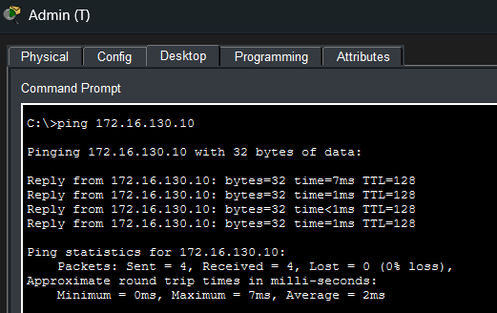
Admin (T) can access the Web server via http in Temple:
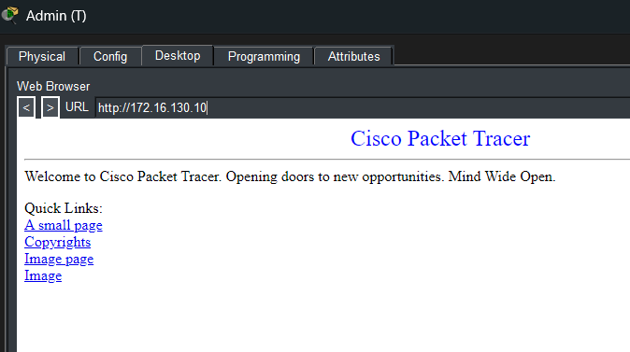
Admin (T) can ping Email server:
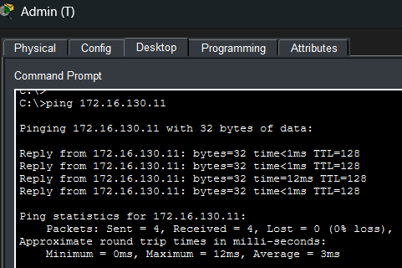
Admin can ping the internet (ISP):
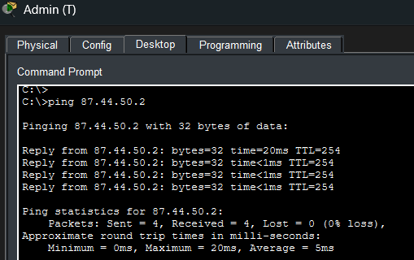
Admin (T) Cannot reach other Temple Vlans:
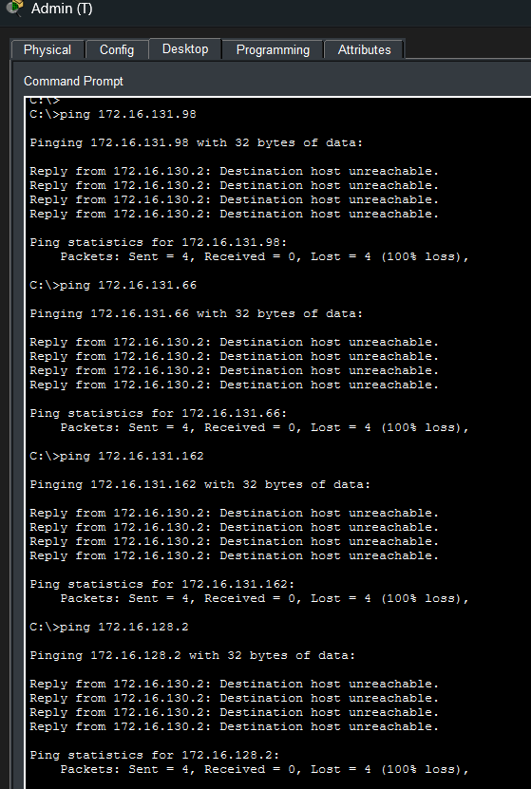
Admin (T) cannot reach Connolly Vlans:
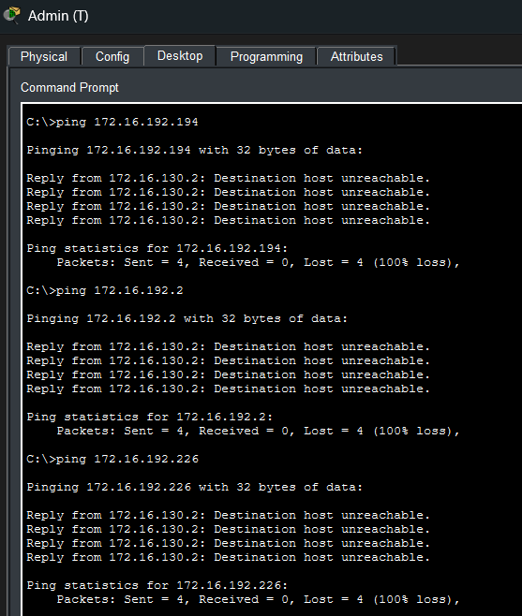
show access-lists ADMIN_RESTRICT on Temple’s router proves access-list is filtering as intended:
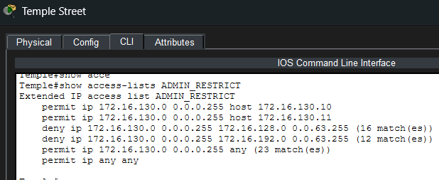
Admin (C) can access the Web server via http in Temple across WAN:
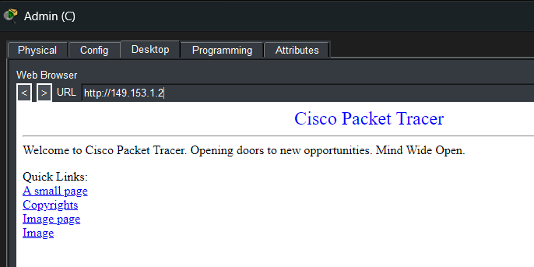
Admin (C) can ping the internet (ISP):
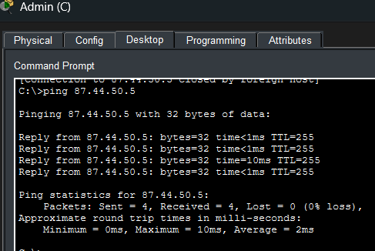
Admin (C) Cannot reach other Connolly Vlans:
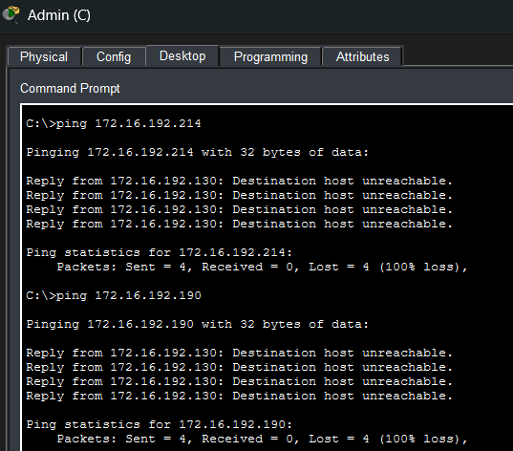
Admin (C) cannot reach Temple Vlans:
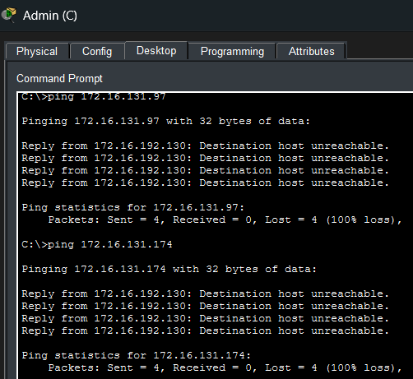
show access-lists ADMIN_RESTRICT on Connolly’s router proves access-list is filtering as intended:
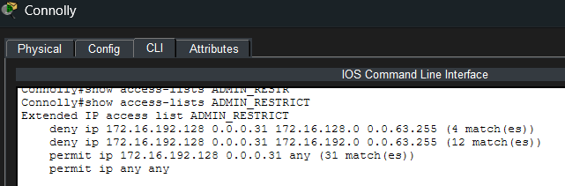

(C) “HR should be allowed to access all parts of the network, but all other aspects of the network should not be able to access HR staff”
Temple HR can reach all internal Vlans:
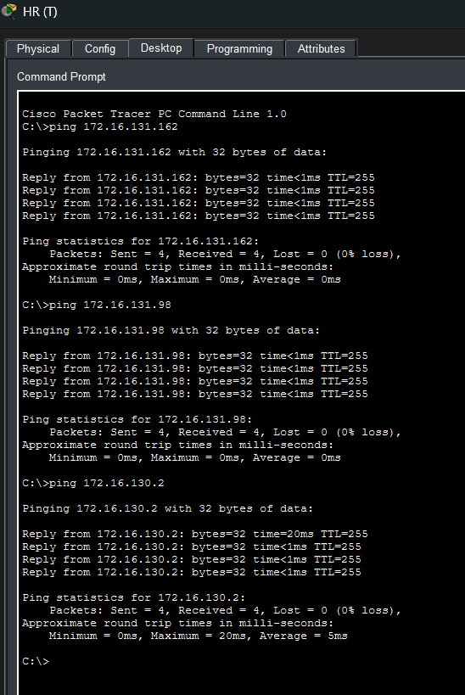
Temple HR can reach Connolly site:
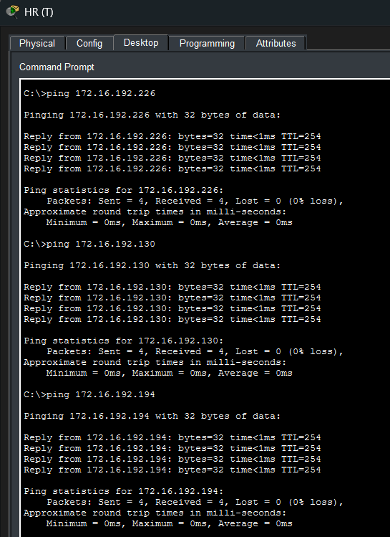
Other Temple Vlans cannot reach Temple HR:
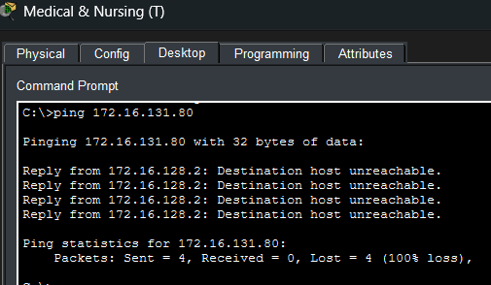
Connolly Vlans cannot reach Temple HR:
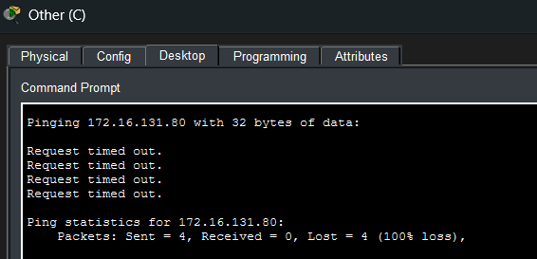
show access-lists HR_PROTECTION on Temple’s router proves access-list is filtering as intended:
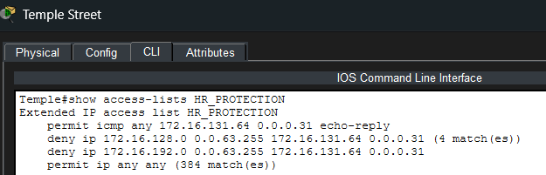
Connolly HR can reach all internal Vlans:
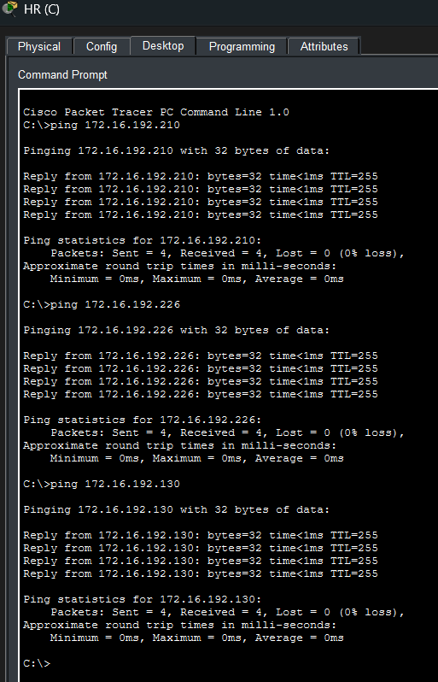
Connolly HR can reach Temple Site:
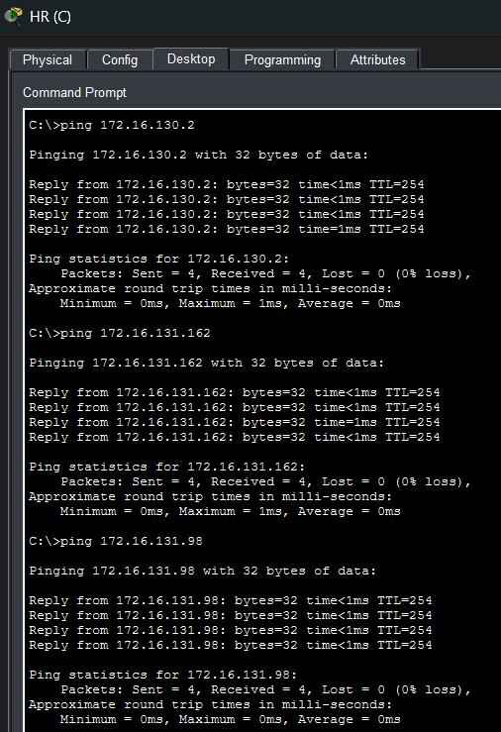
Other Connolly Vlans cannot reach Connolly HR:
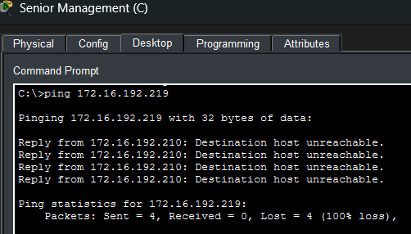
Temple Vlans cannot reach Connolly HR:
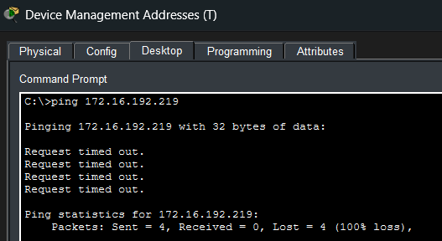
show access-lists HR_PROTECTION on Connolly’s router proves access-list is filtering as intended:

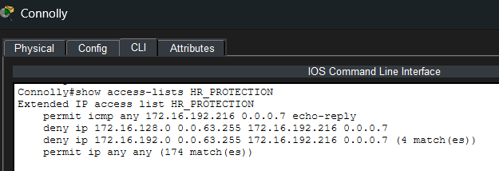
(D) “Allow the Internet to access the servers in Temple Street for email and Internet traffic only. Block access to all other parts of the network.” ISP can access Web and Email servers in Temple Street
ISP can reach Web Server (HTTP + HTTPS):
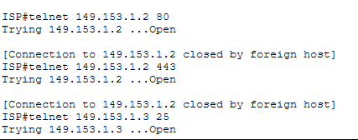
ISP can reach Email Server (SMTP):
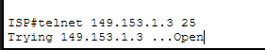
ISP cannot access internal Temple Vlans:
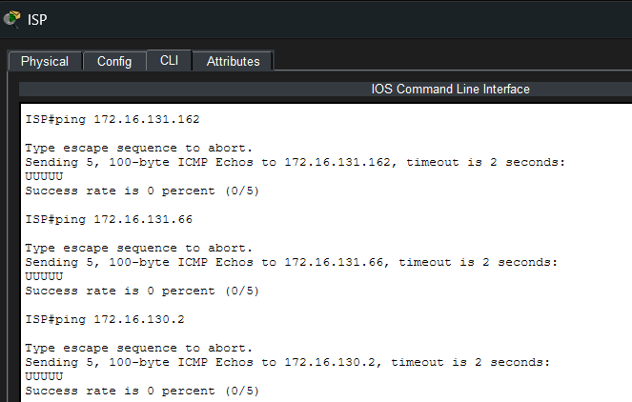
show access-lists PUBLIC_SERVERS on Temple’s router proves access-list is filtering as intended:
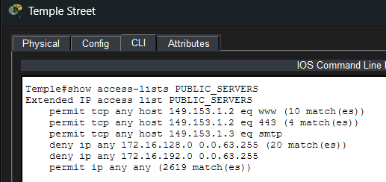
ACL is applied to WAN interface:
